

Dr. Mary, Kennedy inc.
2019-04-18
Dr. Kennedy
79345 Little Lights, Mclaughlinbury, FM 40876
Phone: 9711341667
Fax: 6225678701

Re: Stephanie, Wiley
PHN: 3229491413
Birthdate: 25-Oct-1947
Address: 343 Cynthia Gardens Suite 543, Lake Melissaview, FL 68242
Patient number: 903203323

To Whom It May Concern:

This is a medical letter to state the above patient is pregnant with expected delivery date of 30-Oct-2025. Hoping this information is satisfactory for your requirements.

Thank you.

Sincerely,
Dr. Mary, Kennedy
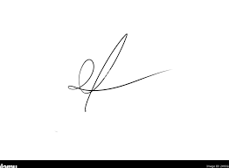
FRCS© NCMP
Clinical Assistant Professor, UBC
Department of Obstetrics and Gynecology SMH

